26th July 2018

**YOKOHAMA Develops World's First Technology for Producing Isoprene from Biomass**

YOKOHAMA has developed the world’s first technology capable of efficiently producing isoprene from a biomass. The new breakthrough is the result of joint research with RIKEN and Zeon Corporation. Isoprene is a raw material in the production of synthetic rubber (polyisoprene rubber) used in automobile tyres and other applications. Industrial isoprene currently is produced as a by-product of naphtha pyrolysis. The development of this new technology for synthesizing isoprene will reduce dependence on petroleum and contribute to the reduction of carbon dioxide (CO2), which is considered a cause of global warming.   
  
YOKOHAMA, RIKEN and Zeon began joint research in 2013 and in 2015 discovered a new isoprene-synthesizing process using a computer-based in-silico metabolic design technology*. Further development of this new technology has led to the creation of cells with excellent isoprene-synthesizing capability based on a new artificial pathway and highly active enzymes. The new technology has succeeded in creating cells with the in-vivo capability of generating isoprene from a biomass (sugar) that serves as the starting material. The in-vivo generated isoprene is then polymerized to achieve synthesis of polyisoprene rubber. The research leading to this new technology took advantage of the cell design and plant science technologies of the RIKEN Center for Sustainable Resource Science (CSRS).   
*A technology for designing new artificial metabolic reactions on computers  
  
It is widely understood that isoprene is produced naturally from mevalonic acid (an intermediate substance formed from sugar) through a five-stage reaction, but the new artificial pathway constructed through the joint research reduces that process to two stages. Furthermore, the highly active enzymes possess a phenomenal isoprene-producing capability that is not achievable by natural enzymes. Introducing this artificial pathway and these enzymes into colon bacilli gives the bacteria an isoprene-generating ability that it lacks in nature and enables an efficient artificial synthesis of isoprene. YOKOHAMA has confirmed that this technology can also be applied to butadiene-based synthetic rubber and other diene rubbers.   
  
RIKEN is Japan’s only comprehensive research institution for the natural sciences. RIKEN CSRS is dedicated to the realization of a sustainable society through its research in the field of biological functions, especially its basic research on the effective use of plant-microorganism bioprocesses. Zeon, a manufacturer of synthetic rubbers, places its research emphasis on polymerization catalyst technology and enhancing the performance of synthetic rubbers. YOKOHAMA is a comprehensive manufacturer of tyre and rubber products and is actively engaged in research on utilizing biomass derived from plants, which is carbon-neutral (CO2 emission levels=CO2 absorption levels)

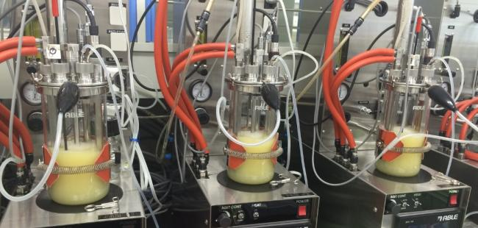

*In-cell (in vivo) synthesis of isoprene*

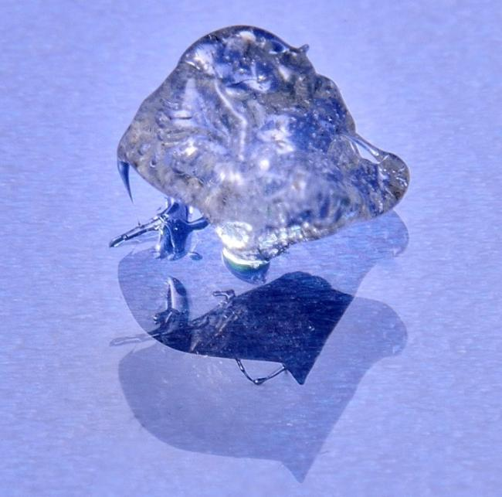

*Polyisoprene rubber polymerized using the new technology*